[](https://utahbusiness.com/)

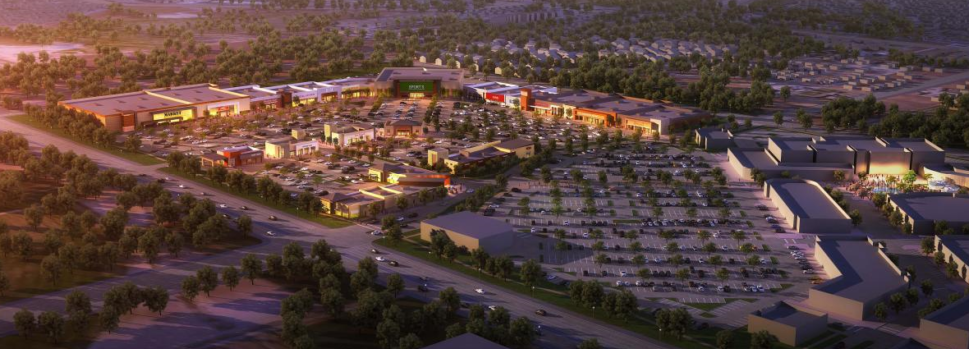

[CenterCal Properties’ Mountain View Village in Riverton Announces Eleven Newly Signed Retail and Restaurant Partners](https://utahbusiness.com/centercal-properties-mountain-view-village-riverton-announces-eleven-newly-signed-retail-restaurant-partners/)

[PRESS RELEASES](https://utahbusiness.com/category/press-releases/) , [REAL ESTATE](https://utahbusiness.com/category/topics/real-estate/) , [RESTAURANTS & FOOD](https://utahbusiness.com/category/topics/restaurant/) , [RETAIL](https://utahbusiness.com/category/topics/retail/) , [WASATCH FRONT](https://utahbusiness.com/category/regions/wasatch-front/)Press Release Feb 13, 2018

Riverton—CenterCal Properties’ newest mixed-use project, Mountain View Village in Riverton, announced eleven retailers and restaurants that have signed leases for its opening in Summer 2018. Mountain View Village will be the company’s latest and best example of its focus on placemaking.

“Our work in Utah is focused on developing and building places where people in the community can spend time in myriad activities, including working in the planned office space, dining, visiting with family and friends, and attending community events,” noted Fred Bruning, chief executive officer of CenterCal. “Mountain View Village will be a place where people can gather and connect with each other.”

CenterCal’s goal with its placemaking projects focuses on creating spaces that bring people together in a wide variety of ways, with offerings that include public gathering spaces, family events, lifestyle amenities, and open-air concerts to which the local community is invited.

“Riverton is growing rapidly, and we believe that Mountain View Village will be a wonderful location for us to congregate to enjoy a broad range of dining options, outdoor entertainment and retail shops,” said Riverton Mayor Trent Staggs.

The first phase will have several “big box” and national retail stores, which serve as anchors for specialty stores and restaurants to come in the next phases. When completed, Mountain View Village will be a full-service retail, entertainment and restaurant complex, as well as a beautiful and unique gathering place for families and communities.

The grand opening of phase one of Mountain View Village is scheduled for Summer 2018 and includes current leases with:

* **Harmons (with gas station)**
* **Michaels**
* **Ulta**
* **PetSmart**
* **T.J. Maxx/HomeGoods**
* **MOD Pizza**
* **Capriotti’s**
* **The Good Feet Store**
* **Sprint**
* **AT&T**
* **Verizon**

“As the general contractor for Mountain View Village, one of the best things about working with CenterCal is that it is an opportunity to be a true partner in helping to unify these unique communities,” said David Layton, president of Layton Construction. “We share their vision of Mountain View Village being a place that will bring people together.”

In addition to the community gathering space, a key feature of the development will be the beautiful eagle statue and show fountain area. CenterCal commissioned renowned sculptor Brian Keith to create a 20-foot bronze cast eagle statue which will be the fountain centerpiece. The eagle statue’s unveiling, coupled with the summer grand opening plans, will be announced soon.

For more information about the growth and development of Mountain View Village, visit the company’s website.